**Mukesh Patel School of Technology Management & Engineering**

**Computer Engineering Department**

Program: MCA SEM I, A.Y.24-25

**Course:**

**Web Technologies**

LAB Manual

PART A

**Program 1- Week 1 and Week 2**

**PART B**

**B.1 Software Code written by student:**

**index.html**

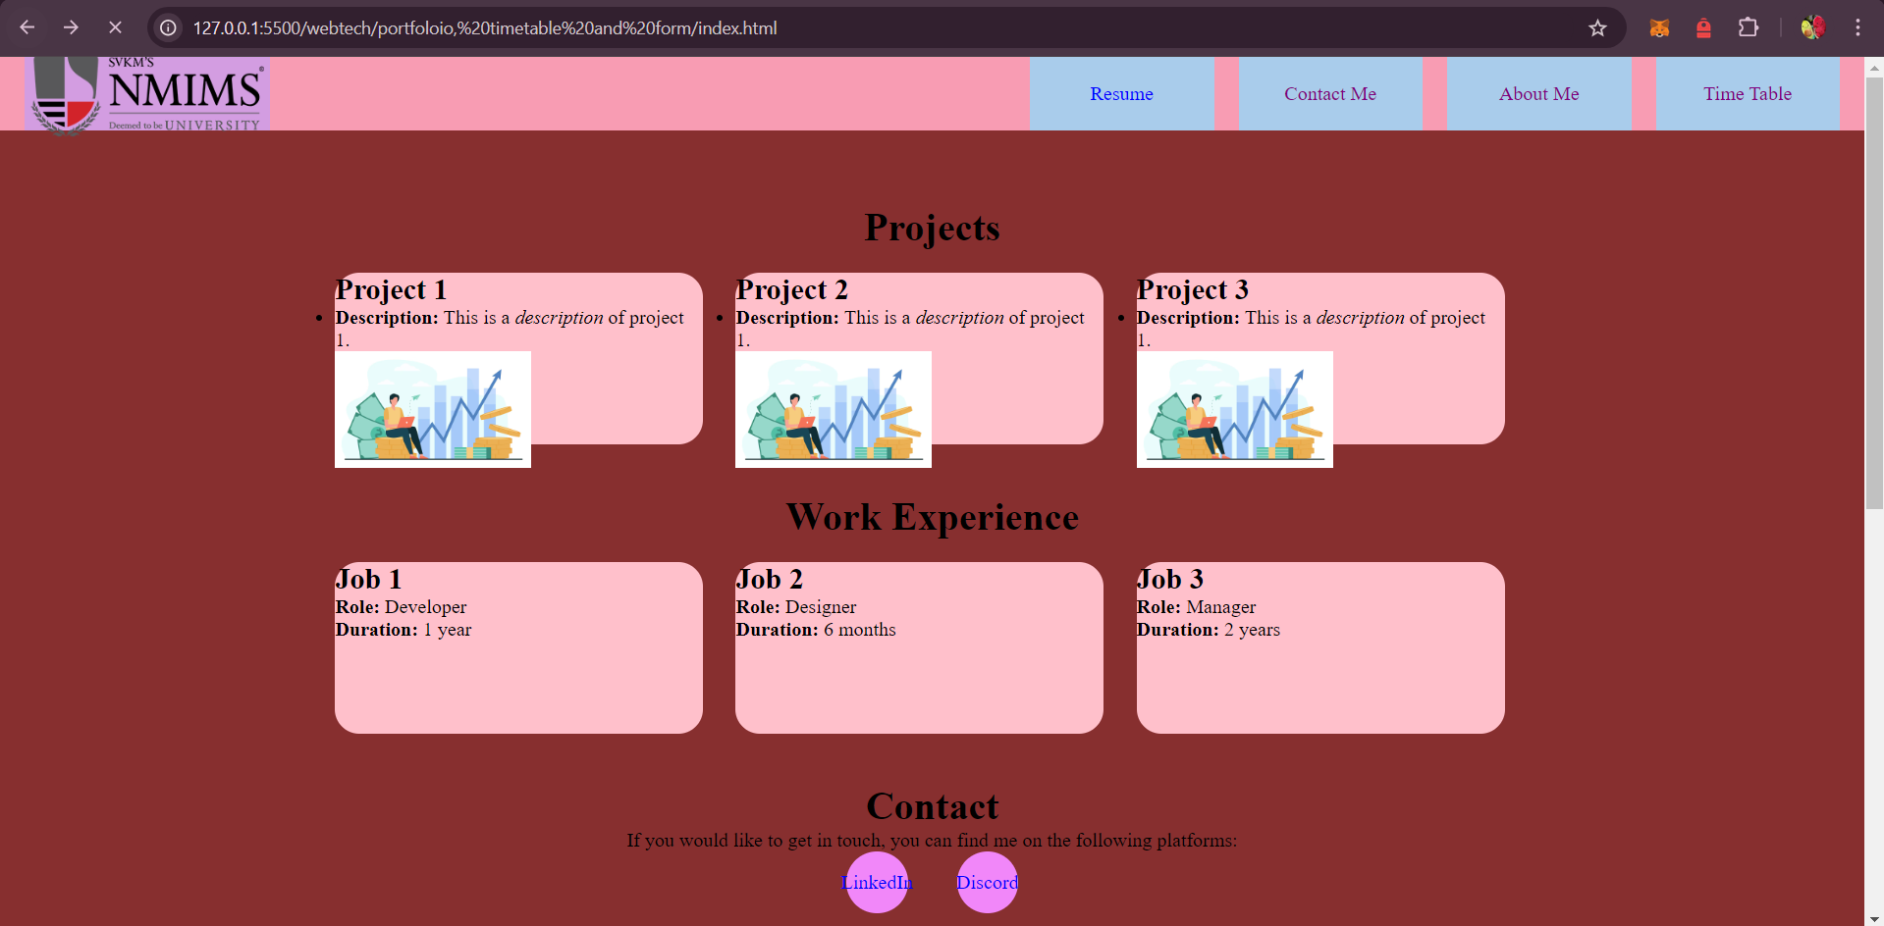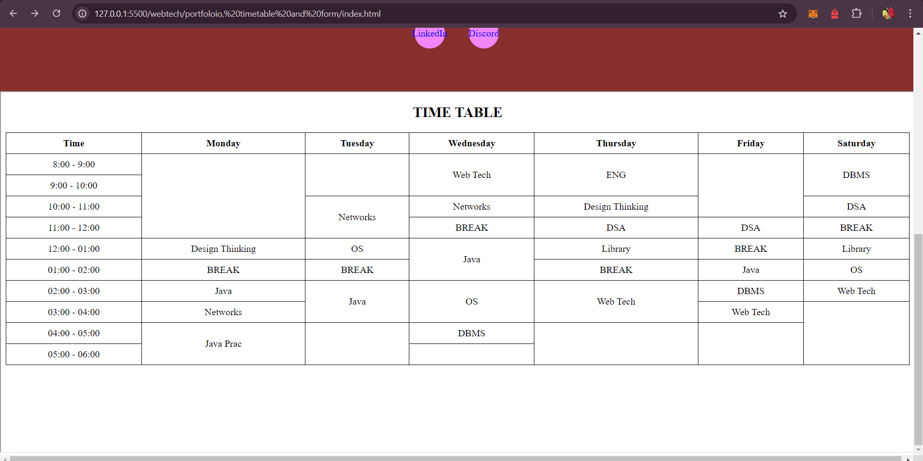

<!DOCTYPE html>

<html lang="en">

<head>

<meta charset="UTF-8">

<meta name="viewport" content="width=device-width, initial-scale=1.0">

<title>My Portfolio</title>

<link rel="stylesheet" href="styles.css">

<style>

a:link {

color: blue;

}

a:visited {

color: purple;

}

a:hover {

color: red;

}

a:active {

color: green;

}

</style>

</head>

<body>

<div class="header">

<div class="logo">

<img src="nmims.png" alt="Logo">

</div>

<div class="header-links">

<a href="resume.html">

<div class="resume">Resume</div>

</a>

<a href="contactme.html">

<div class="contactme">Contact Me</div>

</a>

<a href="about.html">

<div class="aboutme">About Me</div>

</a>

<a href="timetable.html">

<div class="timetable">Time Table</div>

</a>

</div>

</div>

<div class="body">

<h1 id="projects" class="projname">Projects</h1><br>

<div class="projects">

<div class="projectCard">

<h2>Project 1</h2>

<ul>

<li><strong>Description:</strong> This is a <em>description</em> of project 1.</li>

</ul> <img src="stocks.png" alt="Project 1 Image">

</div>

<div class="projectCard">

<h2>Project 2</h2>

<ul>

<li><strong>Description:</strong> This is a <em>description</em> of project 1.</li>

</ul>

<img src="stocks.png" alt="Project 2 Image">

</div>

<div class="projectCard">

<h2>Project 3</h2>

<ul>

<li><strong>Description:</strong> This is a <em>description</em> of project 1.</li>

</ul> <img src="stocks.png" alt="Project 3 Image">

</div>

</div>

<h1 id="workexp" class="workexpname">Work Experience</h1><br>

<div class="workexp">

<div class="workcard">

<h2>Job 1</h2>

<p><strong>Role:</strong> Developer</p>

<p><strong>Duration:</strong> 1 year</p>

</div>

<div class="workcard">

<h2>Job 2</h2>

<p><strong>Role:</strong> Designer</p>

<p><strong>Duration:</strong> 6 months</p>

</div>

<div class="workcard">

<h2>Job 3</h2>

<p><strong>Role:</strong> Manager</p>

<p><strong>Duration:</strong> 2 years</p>

</div>

</div>

<h1 id="contact">Contact</h1>

<p>If you would like to get in touch, you can find me on the following platforms:</p>

<div class="footer">

<div class="socials">

<a href="https://linkedin.com">LinkedIn</a>

</div>

<div class="socials">

<a href="https://discord.com">Discord</a>

</div>

</div>

</div>

<iframe src="timetable.html" title="Example Frame" width=100% height="600"></iframe>

</body>

</html>

**contactme.html**

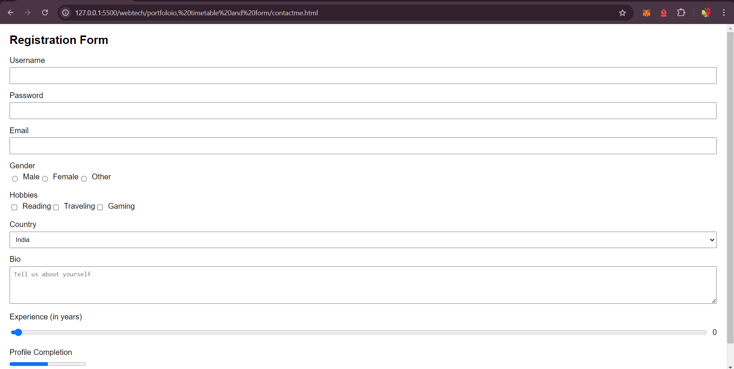

<!DOCTYPE html>

<html lang="en">

<head>

<meta charset="UTF-8">

<meta name="viewport" content="width=device-width, initial-scale=1.0">

<title>Document</title>

</head>

<style>

body {

font-family: Arial, sans-serif;

margin: 20px;

}

.form-group {

margin-bottom: 15px;

}

label {

display: block;

margin-bottom: 5px;

}

input,

select,

textarea {

width: 100%;

padding: 8px;

box-sizing: border-box;

}

.checkbox-group,

.radio-group {

display: flex;

align-items: center;

}

.checkbox-group input,

.radio-group input {

width: auto;

margin-right: 10px;

}

.range-group {

display: flex;

align-items: center;

}

.range-group input[type="range"] {

flex-grow: 1;

}

.range-value {

margin-left: 10px;

}

</style>

</head>

<body>

<h2>Registration Form</h2>

<form>

<div class="form-group">

<label for="username">Username</label>

<input type="text" id="username" name="username" required>

</div>

<div class="form-group">

<label for="password">Password</label>

<input type="password" id="password" name="password" required>

</div>

<div class="form-group">

<label for="email">Email</label>

<input type="email" id="email" name="email" required>

</div>

<div class="form-group">

<label>Gender</label>

<div class="radio-group">

<input type="radio" id="male" name="gender" value="male">

<label for="male">Male</label>

<input type="radio" id="female" name="gender" value="female">

<label for="female">Female</label>

<input type="radio" id="other" name="gender" value="other">

<label for="other">Other</label>

</div>

</div>

<div class="form-group">

<label>Hobbies</label>

<div class="checkbox-group">

<input type="checkbox" id="hobby1" name="hobbies" value="Reading">

<label for="hobby1">Reading</label>

<input type="checkbox" id="hobby2" name="hobbies" value="Traveling">

<label for="hobby2">Traveling</label>

<input type="checkbox" id="hobby3" name="hobbies" value="Gaming">

<label for="hobby3">Gaming</label>

</div>

</div>

<div class="form-group">

<label for="country">Country</label>

<select id="country" name="country">

<option value="india">India</option>

<option value="us">United States</option>

<option value="uk">United Kingdom</option>

<option value="canada">Canada</option>

</select>

</div>

<div class="form-group">

<label for="bio">Bio</label>

<textarea id="bio" name="bio" rows="4" placeholder="Tell us about yourself"></textarea>

</div>

<div class="form-group">

<label for="experience">Experience (in years)</label>

<div class="range-group">

<input type="range" id="experience" name="experience" min="0" max="20" value="0" oninput="document.getElementById('rangeValue').innerText = this.value">

<span class="range-value" id="rangeValue">0</span>

</div>

</div>

<div class="form-group">

<label for="progress">Profile Completion</label>

<progress id="progress" value="50" max="100">50%</progress>

</div>

<button type="submit">Register</button>

</form>

</body>

</html>

**timetable.html**

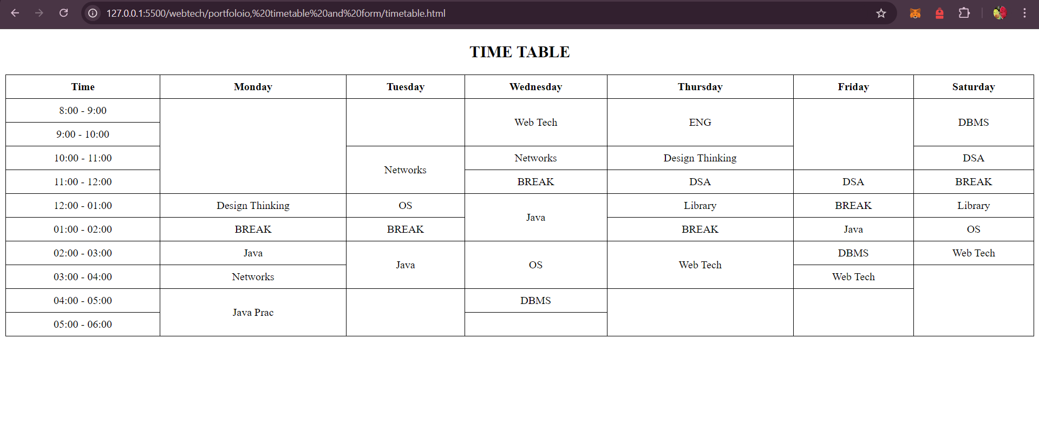

<!DOCTYPE html>

<html lang="en">

<head>

<meta charset="UTF-8">

<meta name="viewport" content="width=device-width, initial-scale=1.0">

<title>Document</title>

<style>

table {

width: 100%;

border-collapse: collapse;

}

th,

td {

border: 1px solid black;

padding: 8px;

text-align: center;

}

</style>

</head>

<body>

<h2 style="text-align: center;">TIME TABLE</h2>

<table>

<thead>

<tr>

<th>Time</th>

<th>Monday</th>

<th>Tuesday</th>

<th>Wednesday</th>

<th>Thursday</th>

<th>Friday</th>

<th>Saturday</th>

</tr>

</thead>

<tbody>

<tr>

<td>8:00 - 9:00</td>

<th rowspan="4"></th>

<th rowspan="2"></th>

<td rowspan="2">Web Tech</td>

<td rowspan="2">ENG</td>

<td rowspan="3"></td>

<td rowspan="2">DBMS</td>

</tr>

<tr>

<td>9:00 - 10:00</td>

</tr>

<tr>

<td>10:00 - 11:00</td>

<td rowspan="2">Networks</td>

<td>Networks</td>

<td>Design Thinking</td>

<td>DSA</td>

</tr>

<tr>

<td>11:00 - 12:00</td>

<td>BREAK</td>

<td>DSA</td>

<td>DSA</td>

<td>BREAK</td>

</tr>

<tr>

<td>12:00 - 01:00</td>

<td>Design Thinking</td>

<td>OS</td>

<td rowspan="2">Java</td>

<td>Library</td>

<td>BREAK</td>

<td>Library</td>

</tr>

<tr>

<td>01:00 - 02:00</td>

<td>BREAK</td>

<td>BREAK</td>

<td>BREAK</td>

<td>Java</td>

<td>OS</td>

</tr>

<tr>

<td>02:00 - 03:00</td>

<td>Java</td>

<td rowspan="2">Java</td>

<td rowspan="2">OS</td>

<td rowspan="2">Web Tech</td>

<td>DBMS</td>

<td>Web Tech</td>

</tr>

<tr>

<td>03:00 - 04:00</td>

<td>Networks</td>

<td>Web Tech</td>

<td rowspan="3"></td>

</tr>

<tr>

<td>04:00 - 05:00</td>

<td rowspan="2">Java Prac</td>

<td rowspan="2"></td>

<td>DBMS</td>

<td rowspan="2"></td>

<td rowspan="2"></td>

</tr>

<tr>

<td>05:00 - 06:00</td>

<td></td>

</tr>

</tbody>

</table>

</body>

</html>

**about.html**

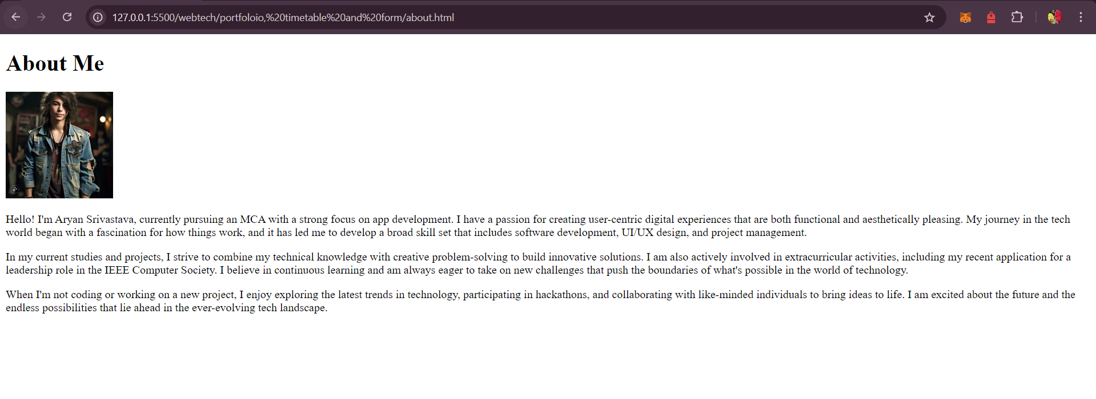

<!DOCTYPE html>

<html lang="en">

<head>

<meta charset="UTF-8">

<meta name="viewport" content="width=device-width, initial-scale=1.0">

<title>About Me - Aryan Srivastava</title>

</head>

<body>

<h1>About Me</h1>

<img src="profile.jpg" alt="Aryan Srivastava" width="150" height="150">

<p>Hello! I'm Aryan Srivastava, currently pursuing an MCA with a strong focus on app development. I have a passion for creating user-centric digital experiences that are both functional and aesthetically pleasing. My journey in the tech world began with

a fascination for how things work, and it has led me to develop a broad skill set that includes software development, UI/UX design, and project management.</p>

<p>In my current studies and projects, I strive to combine my technical knowledge with creative problem-solving to build innovative solutions. I am also actively involved in extracurricular activities, including my recent application for a leadership

role in the IEEE Computer Society. I believe in continuous learning and am always eager to take on new challenges that push the boundaries of what's possible in the world of technology.</p>

<p>When I'm not coding or working on a new project, I enjoy exploring the latest trends in technology, participating in hackathons, and collaborating with like-minded individuals to bring ideas to life. I am excited about the future and the endless possibilities

that lie ahead in the ever-evolving tech landscape.</p>

</body>

</html>